Civil war in Rwanda

UNSC Resolution: | 978
Date of adoption: | 27 February 1995
Operative paragraph: | 4
Demand number: | 978.0411

Carla Winston

Wording of demand
Such attacks immediately cease

List of addressees of the demand
Ex-Rwandan Government, Interahamwe

Short-term compliance

Description of the addressee(s)’ conduct

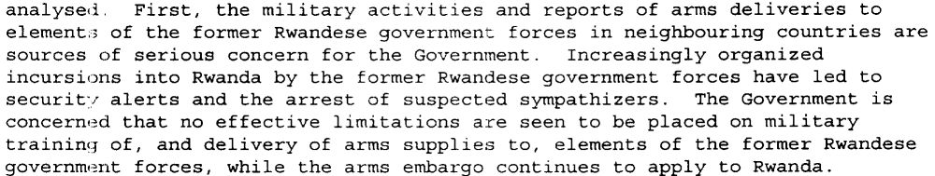
(Report of the Secretary-General on the United Nations Assistance Mission for Rwanda, UN Doc. S/1995/457 (4 June 1995), par. 4)

Report of the Secretary-General on the United Nations Assistance Mission for Rwanda, UN Doc. S/1995/678 (8 August 1995), par. 11)

97. Highly reliable eyewitnesses described training of insurgents being carried out at Zairian military camp, 20 kilometres north of Bukavu and at Bunia near Lake Albert. Other locations where training was said to be taking place include the Virunga Forest north of Goma, Idjwi Island in Lake Kivu, Bafwasende in the Kisangani area and Moba on Lake Tanganyika. According to another highly placed source in the Government of one of the Great Lakes countries, training was being carried out in Masisi, Kalonge, Muhanga, Kibanzo, Panzi, Kamanyola and Idjwi Forest.
98. The training has apparently permitted increased insurgent activity in the form of incursions, a major objective of which is to identify and eliminate potential witnesses of the genocide. The Commission was given a detailed description of the ways in which genocide survivors or those who might give evidence to the Government of Rwanda or the International Tribunal are identified, tracked and killed even if they are in the custody of the Rwandan Government. Some potential witnesses have reportedly been poisoned. According to highly reliable sources, foreign nationals and interests in Rwanda might also be at risk and would be deliberately targeted and killed in the event of an invasion.
(Third report of the International Commission of Inquiry (Rwanda), UN Doc. S/1997/1010 Annex (24 December 1997), par. 97-98) *Information obtained in field visits during July 1996.

Assessment

Short-term compliance
No or marginal compliance (1) | Medium low compliance (2) | Medium high compliance (3) | Full or almost full compliance (4)

Considerations underlying the assessment
Attacks did not cease, training did not cease, and general intimidation and incitement of refugees did not cease.

Medium-term compliance

Description of the addressee(s)’ conduct

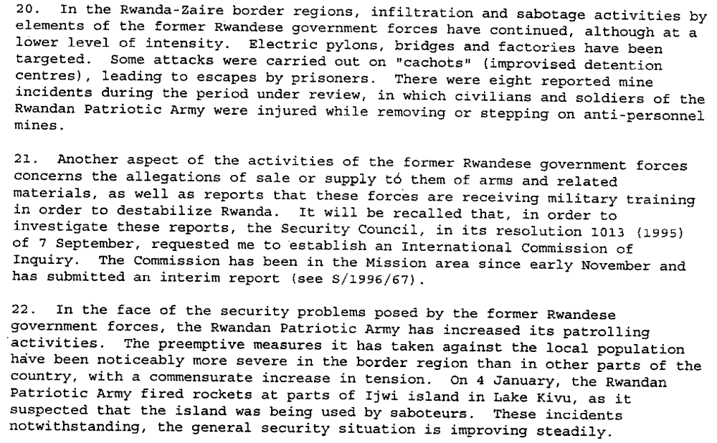
(Progress Report of the Secretary-General on the United Nations Assistance Mission for Rwanda, UN Doc. S/2996/61 (30 January 1996), par. 20-22)

Assessment

Medium-term compliance
No or marginal compliance (1) | Medium low compliance (2) | Medium high compliance (3) | Full or almost full compliance (4)

Considerations underlying the assessment
Due to reduced capacity and increased measures taken by the Government of Rwanda, attacks lessened. They did not completely cease, but they lessened.

Depth of demand

Assessment

Level of depth of demand
Low depth of demand (1) | Medium depth of demand (2) | High depth of demand (3)

Considerations underlying the assessment
Ceasing attacks would not imperil the existence of these groups or their control over the refugee camps, but it would make it impossible to gain any future power in Rwanda except through negotiations, an unlikely prospect.

Level of confidence about coding decisions

Level of confidence about coding decision
Extremely high | High | Moderate

Comments to IPI (if any)

Civil war in Rwanda

UNSC Resolution: | 997
Date of adoption: | 9 June 1995
Operative paragraph: | 7
Demand number: | 997.0711

Carla Winston

Wording of demand
Continue to implement the agreements made between them, in particular the Status of Mission Agreement of 5 November 1993 and any subsequent agreement concluded to replace that Agreement in order to facilitate the implementation of the new mandate

List of addressees of the demand
Government of Rwanda

Short-term compliance

Description of the addressee(s)’ conduct

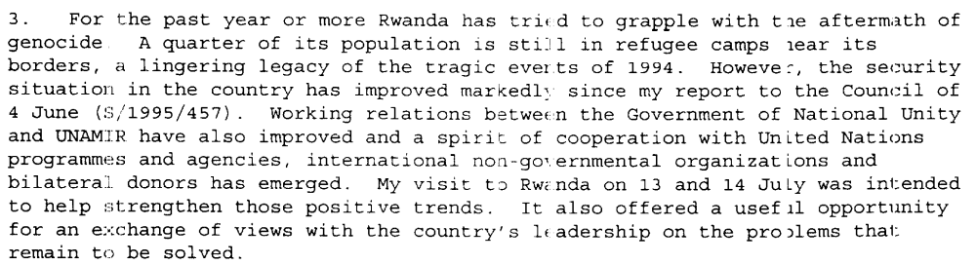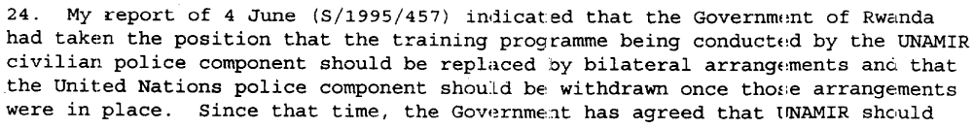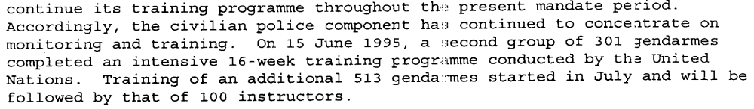
Report of the Secretary-General on the United Nations Assistance Mission for Rwanda, UN Doc. S/1995/678 (8 August 1995), par. 3, 24)

Assessment

Short-term compliance
No or marginal compliance (1) | Medium low compliance (2) | Medium high compliance (3) | Full or almost full compliance (4)

Considerations underlying the assessment
Improved relations and compliance, but with remaining requests for changing future UNAMIR tasks.

Medium-term compliance

Description of the addressee(s)’ conduct

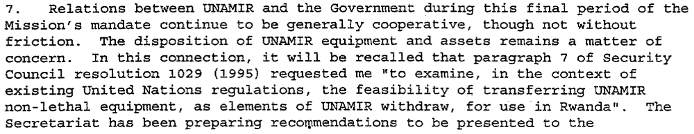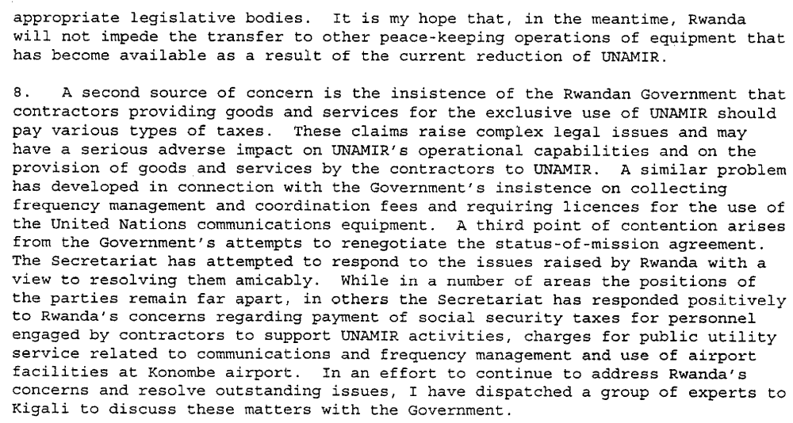
Progress Report of the Secretary-General on the United Nations Assistance Mission for Rwanda, UN Doc. S/2996/61 (30 January 1996), par. 7-8)

Assessment

Medium-term compliance
No or marginal compliance (1) | Medium low compliance (2) | Medium high compliance (3) | Full or almost full compliance (4)

Considerations underlying the assessment
While generally cooperative, the Government of Rwanda’s insistence on the tax arrangements for UNAMIR contractors had the potential to adversely impact UNAMIR operations.

Depth of demand

Assessment

Level of depth of demand
Low depth of demand (1) | Medium depth of demand (2) | High depth of demand (3)

Considerations underlying the assessment
The Government of Rwanda needed the presence of UNAMIR for certain purposes, and successfully negotiated with the United Nations to operating conditions in its favor. Therefore, there was very little risk in complying with this demand.

Level of confidence about coding decisions

Level of confidence about coding decision
Extremely high | High | Moderate

Comments to IPI (if any)

Civil war in Rwanda

UNSC Resolution: | 997
Date of adoption: | 9 June 1995
Operative paragraph: | 8
Demand number: | 997.0812

Carla Winston

Wording of demand
Continue to facilitate their delivery and distribution

List of addressees of the demand
Government of Rwanda

Short-term compliance

Description of the addressee(s)’ conduct

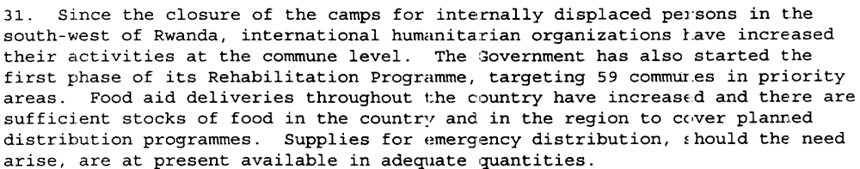Report of the Secretary-General on the United Nations Assistance Mission for Rwanda, UN Doc. S/1995/678 (8 August 1995), par. 31)

Assessment

Short-term compliance
No or marginal compliance (1) | Medium low compliance (2) | Medium high compliance (3) | Full or almost full compliance (4)

Considerations underlying the assessment

Closure of the camps represents a set-back to the ability to distribute aid, but this was offset by increased efforts at the commune level.

Medium-term compliance

Description of the addressee(s)’ conduct

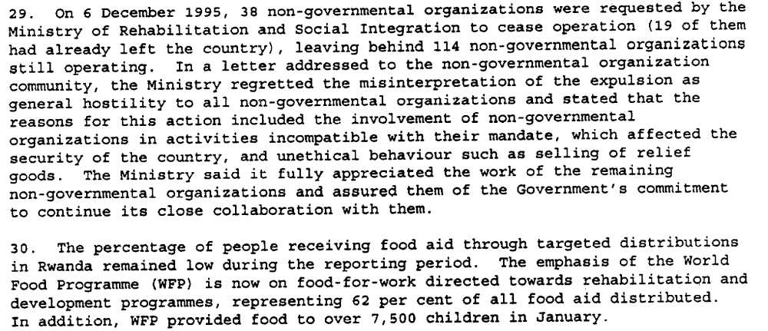(Report of the Secretary-General on the United Nations Assistance Mission for Rwanda, UN Doc. S/1996/149 (29 February 1996), par. 29-30)

For an international relief operation to work, the United Nations would need Rwanda's cooperation, aid officials said. The rebels have cut the road from Uganda to Goma over which most of the food for the camps was trucked, so food aid and medicine would have to be brought through Rwanda.
Mr. Ndahiro said Rwanda would be willing to allow relief supplies through, but only if the aid remained in Rwanda, as a lure to bring refugees back.

(“War in Eastern Zaire Leaves Relief Agencies Scrambling,” by James C. McKinley Jr. The New York Times, November 4, 1996. http://www.nytimes.com/1996/11/04/world/war-in-eastern-zaire-leaves-relief-agencies-scrambling.html?scp=10&sq=rwanda+humanitarian&st=nyt )

The Tutsi-led government of Rwanda also has authorized aid agencies to deliver food and medicine from its territory to Hutus in the rebel-held east.
(“Zairian Tutsi Rebels Permit Humanitarian Aid Corridor,” CNN, November 10, 1996. http://www.cnn.com/WORLD/9611/10/zaire/index.html

The Rwandan government has said so far that it welcomes international humanitarian aid but opposes the dispatch of foreign troops to its territory.

(“Refugees' swift exodus from Zaire slows 3-day journey of the 500,000Rwandans said to be largest, fastest ever.” Milwaukee Journal-Sentinel, November 18, 1996. http://www.highbeam.com/doc/1P2-6486632.html)

Assessment

Medium-term compliance
No or marginal compliance (1) | Medium low compliance (2) | Medium high compliance (3) | Full or almost full compliance (4)

Considerations underlying the assessment
Although it initially preferred that all humanitarian aid destined for returning refugees remain inside Rwanda, in short order the Government of Rwanda changed its mind and allowed its territory to be used as a base for sending humanitarian relief supplies into eastern Zaire.

Depth of demand

Assessment

Level of depth of demand
Low depth of demand (1) | Medium depth of demand (2) | High depth of demand (3)

Considerations underlying the assessment
As the Government of Rwanda did not have the ability to fully aid its own internally displaced persons, due to lack of capacity, it was in the Government’s best interests to aid international organizations to distribute donated aid to those in need.

Level of confidence about coding decisions

Level of confidence about coding decision
Extremely high | High | Moderate

Comments to IPI (if any)
It was difficult to find sources on Rwanda’s compliance in distributing humanitarian aid after the end of UNAMIR’s mandate.

Civil war in Rwanda

UNSC Resolution: | 1011
Date of adoption: | 16 August 1995
Operative paragraph: | 38
Demand number: | 1011.0311

Carla Winston

Wording of demand
Cooperate with the Commission’s investigation

List of addressees of the demand
Government of Rwanda

Short-term compliance

Description of the addressee(s)’ conduct

13. The International Commission, having established an administrative base at the United Nations Office at Nairobi, visited Rwanda and Zaire and met in each country with senior government officials and the heads of United Nations agencies and representatives of NGOs operating among the refugees (see appendix).

16. That afternoon, the International Commission met with the Minister of Foreign Affairs of Rwanda, H.E. Mr. Anastase Gasana. The Commissioner met the following morning with the Vice-President and Minister of Defence, Major-General Paul Kagame.
17. During the meeting with the Vice-President, in addition to requesting general assistance in the discharge of the Commission’s mandate, the Chairman requested the particular cooperation of the Rwandese Government in facilitating a visit by the Commission to Iwawa island in Lake Kivu. The island, which is Rwandese territory, had been the scene of a battle a few days before between the Rwandese Patriotic Army (RPA) and Rwandan insurgents apparently controlled by the former Rwandan government forces. A quantity of weapons and military matériel, as well as a number of prisoners, had been captured there.
18. The Commission’s visit to Iwawa island took place the next day, 10 November 1995. The danger from land-mines, which had been heavily and indiscriminately laid on the island, and the time constraints imposed by limitations on the means of transportation available, prevented the Commission from undertaking a comprehensive study of the site and interviewing in depth the prisoners presented to it.
19. Nevertheless, the Commission was able to inspect weapons, explosives and other military equipment both on the shore and at another site further inland. Most of the weapons inspected were found to be old and unserviceable, while the new matériel, still wrapped in plastic bags, mostly comprised unassembled machine-guns. The Commission was later informed by the RPA senior officer present that some weapons in working order had been removed from the island and distributed among the RPA, but that none of these had been new.
20. The Chairman and some members of the Commission then interviewed some young men and a senior non-commissioned officer of the former Rwandan government forces who, they were informed by the RPA officer present, had been captured on the island. The Commission members were obliged to use the RPA officer as an interpreter in their interviews, but had no reason to doubt that the interpretation was accurate. The young men were informed of the nature of the International Commission and agreed to answer questions posed by it. The answers they gave indicated that the men were Rwandans, and had been living in Mugunga Camp near Goma, Zaire. They had been undergoing elementary weapons training on the island under the supervision of a military commander of the former Rwandan government forces and a civilian. No foreigners were said to be involved.
21. During its stay in Rwanda, the International Commission also met with representatives of the Office of the United Nations High Commissioner for Refugees (UNHCR) and other United Nations agencies, the International Committee of the Red Cross (ICRC) and a number of NGOs, as well as representatives of major donor countries (see annex). The Commission also established direct working-level links with Rwandan government officials.
22. During November and December 1995, Commission members travelled back to Kigali from time to time to meet with officials there in an effort to gather and analyse as much information as possible that might corroborate the allegations under investigation. However, on the basis of the information made available to it through this channel to date, the Commission has not been able to reach a firm conclusion as to the truth of the allegations.
(Interim report of the International Commission of Inquiry to investigate reports of the sale or supply of arms to former Rwandan government forces in violation of the Security Council arms embargo and allegations that those forces are receiving training to destabilize Rwanda, UN Doc. S/1996/67 Annex 1 (29 January 1996), par. 13, 16-22)

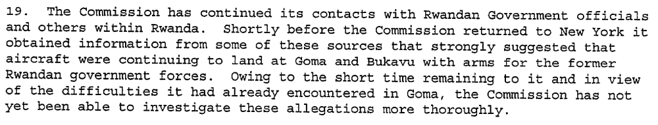
(Report of the International Commission of Inquiry (Rwanda), UN Doc. S/1996/195 Annex 1 (14 March 1996), par. 19)
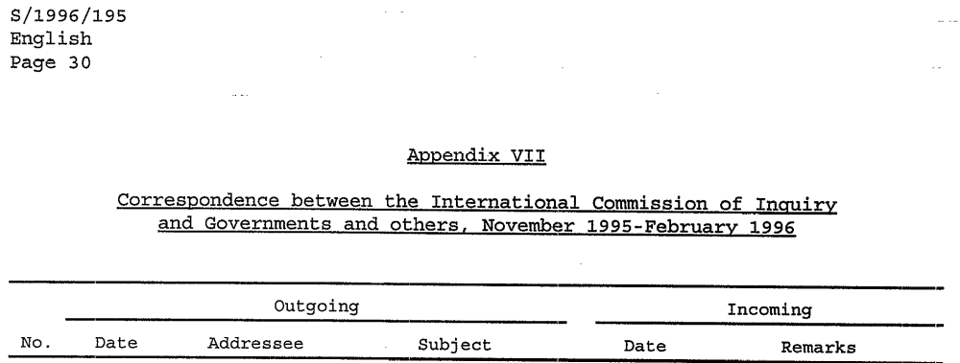

Assessment

Short-term compliance
No or marginal compliance (1) | Medium low compliance (2) | Medium high compliance (3) | Full or almost full compliance (4)

Considerations underlying the assessment
As it was the Government of Rwanda making claims that arms and materiel were flowing to the forces of the former Government, it was in Rwanda’s best interests to cooperate fully with the Commission as it attempted to discern whether the claims were true.

Medium-term compliance

Description of the addressee(s)’ conduct

10. The Commission visited Rwanda from 24 to 29 July [1996] and met there with the Vice-President and Minister of Defence, Major-General Paul Kagame, and other senior officials to renew contacts made earlier. In addition, one Commissioner visited Rwanda a number of times in August and September to maintain official and unofficial contacts, inspect captured weapons and interview prisoners captured in cross-border incursions from Zaire.
11. The Commission was informed that the number and duration of such incursions were increasing and they were penetrating deeper into Rwanda. Some originated in Bukavu and Uvira and came up through Burundi into the south of Rwanda.
12. The information acquired by the Commission concerning fund-raising by and arms sales and deliveries to the former Rwandan government forces and military training to destabilize Rwanda is dealt with in detail below.
(Third report of the International Commission of Inquiry (Rwanda), UN Doc. S/1997/1010 Annex (24 December 1997), par. 10-12)

Assessment

Medium-term compliance
No or marginal compliance (1) | Medium low compliance (2) | Medium high compliance (3) | Full or almost full compliance (4)

Considerations underlying the assessment

As The Government of Rwanda was concerned with arms flowing to the forces of the Former Government of Rwanda, it was in its interests to cooperate as fully as possible with the Commission in order to prove its claims.

Depth of demand

Assessment

Level of depth of demand
Low depth of demand (1) | Medium depth of demand (2) | High depth of demand (3)

Considerations underlying the assessment

Level of confidence about coding decisions

Level of confidence about coding decision
Extremely high | High | Moderate

Comments to IPI (if any)

Civil war in Rwanda

UNSC Resolution: | 1011
Date of adoption: | 16 August 1995
Operative paragraph: | 6
Demand number: | 1011.0611

Carla Winston

Wording of demand
Continue its efforts to create an atmosphere of trust and confidence for the safe return of refugees and take further steps to resolve the humanitarian problems in its prisons, and expedite disposition of the charges against those detained

List of addressees of the demand
Government of Rwanda

Short-term compliance

Description of the addressee(s)’ conduct

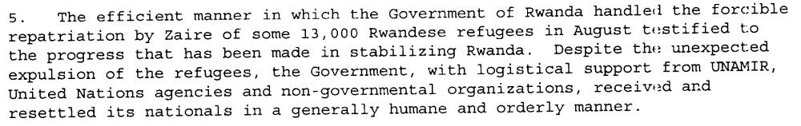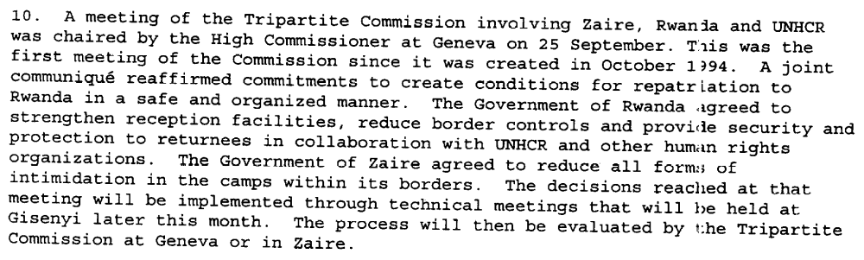
(Progress Report of the Secretary-General on the United Nations Assistance Mission for Rwanda, UN Doc. S/1995/848 (7 October 1995), par. 5, 10)

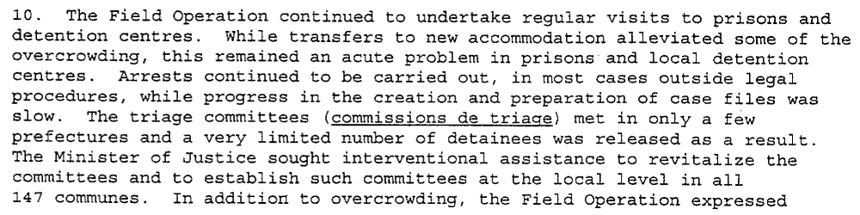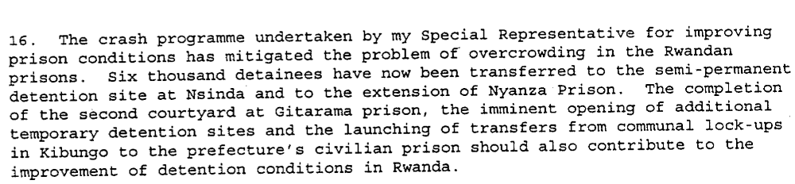
(Progress Report of the Secretary-General on the United Nations Assistance Mission for Rwanda, UN Doc. S/2996/61 (30 January 1996), par. 10, 16)

Assessment

Short-term compliance
No or marginal compliance (1) | Medium low compliance (2) | Medium high compliance (3) | Full or almost full compliance (4)

Considerations underlying the assessment
Compliance for both prison conditions and the return of refugees may have been less vigorous than desired by the Security Council, but significant efforts were made nonetheless.

Medium-term compliance

Description of the addressee(s)’ conduct

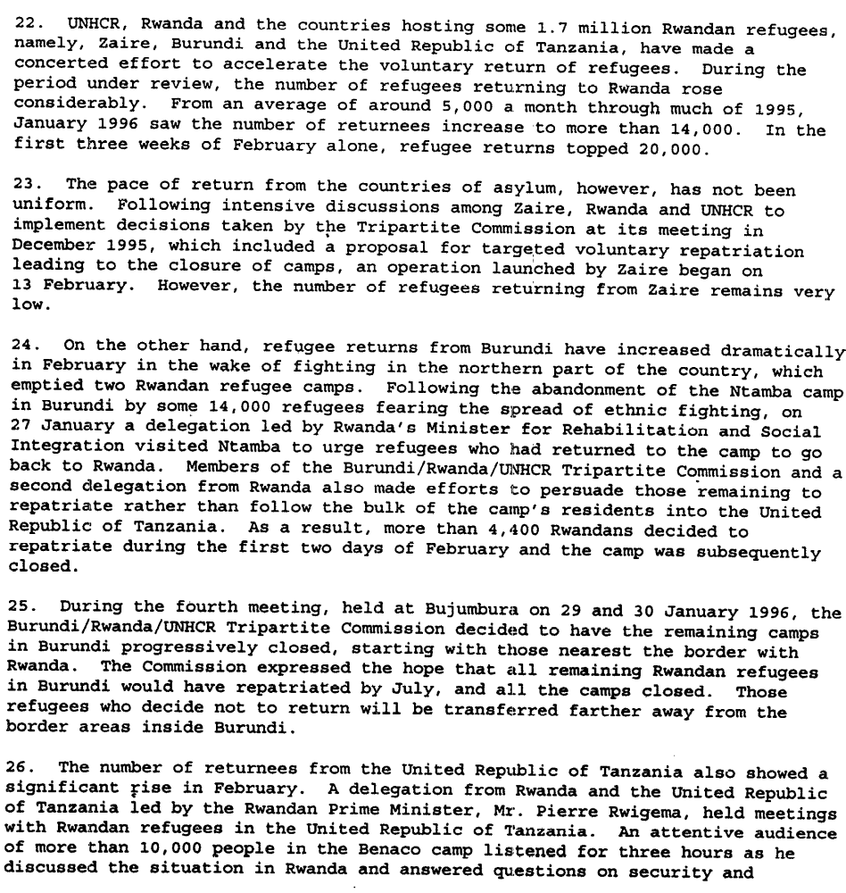(Report of the Secretary-General on the United Nations Assistance Mission for Rwanda, UN Doc. S/1996/149 (29 February 1996), par. 22-26)

Since the fighting began in October, the Zairian government has regularly alleged
that the ADFL has been joined by troops from Rwanda, Uganda, and Burundi. ADFL leaders and the governments of Rwanda, Burundi and Uganda have denied these allegations, but our researchers have collected testimony from both Rwandans and expatriates about the presence of Rwandan soldiers fighting with the ADFL. …
Similarly several witnesses present when Goma was attacked saw vessels leaving the Rwandan shore to fire on the town and said they saw RPA soldiers patrolling the streets of Goma in the days after. Other witnesses reported having seen uniformed RPA troops elsewhere in North Kivu.
A number of refugees reported that camps along the Rwanda border in North Kivu—Kibumba, Kahindo, and Katale—were targeted by mortar fire that came from Rwanda. One refugee who was at Kibumba reported,
“After a week, bombs fell in the camp, and [the Zairian soldiers] left us.
The bombs in the camp came from Rwanda. People were killed by a
mixture of bombs and bullets. There would be bombs for an hour, and
then gunfire and then bombs again.35”
A number of refugees claim that RPA troops participated in the fighting and that
some dressed in civilian clothes were among those who urged them to return to
Rwanda.
(Human Rights Watch, “’Attacked by all Sides’: Civilians and the War in Eastern Zaire.” Vol. 9 no. 1(A), March 1997. p. 18-19)

Assessment

Medium-term compliance
No or marginal compliance (1) | Medium low compliance (2) | Medium high compliance (3) | Full or almost full compliance (4)

Considerations underlying the assessment
Conditions in Rwanda were made ever safer for refugee return, and the Government of Rwanda made concerted efforts to encourage refugees to return voluntarily, but by October of 1996 it had grown weary of waiting and tired of dealing with the security threat the Zairian camps posed. It therefore embarked on a campaign of forced repatriation in cooperation with a group of local Zairian Tutsi groups, which was quite dangerous for the refugees still in Zaire.

Depth of demand

Assessment

Level of depth of demand
Low depth of demand (1) | Medium depth of demand (2) | High depth of demand (3)

Considerations underlying the assessment
The quick and voluntary return of refugees was in Rwanda’s best interest, as it alleviated the long-standing security problem represented by the ex-FAR operating in the Zairian refugee camps. Additionally, relieving overcrowding in prisons would remove some international criticism of Rwanda’s justice system and its plans for prosecuting those complicit in genocide, and was therefore not risky to comply with at all.

Level of confidence about coding decisions

Level of confidence about coding decision
Extremely high | High | Moderate

Comments to IPI (if any)

Civil war in Rwanda

UNSC Resolution: | 1011
Date of adoption: | 16 August 1995
Operative paragraph: | 11
Demand number: | 1011.1112

Carla Winston

Wording of demand
Mark and register and notify to the Committee all imports made by it of arms and related materiel

List of addressees of the demand
Government of Rwanda

Short-term compliance

Description of the addressee(s)’ conduct
(no reports made by Rwanda to the Committee until March 1996)

Assessment

Short-term compliance
No or marginal compliance (1) | Medium low compliance (2) | Medium high compliance (3) | Full or almost full compliance (4)

Considerations underlying the assessment
Report was made on 14 March 1996. It has not been determined whether Rwanda imported arms and neglected to tell the Committee, or whether it imported no arms in this six-month period.

Medium-term compliance

Description of the addressee(s)’ conduct

Accordingly, I wish to inform you that the Committee has received the
following notifications:
(a) On 12 February 1996, from the Government of Singapore, for the export of spare parts for vehicles from Singapore to Rwanda through the entry point of Rusumo, Rwanda, via the port of Dar es Salaam, United Republic of Tanzania, which has also been notified by the Government of Rwanda;
(b) On 14 March 1996, from the Government of Rwanda, for the importation of:
(i) Two (2) boats for patrol purposes from Italy through the entry point of Rusumo, Rwanda, through the port of Dar es Salaam;
(ii) Sixty-five (65) Toyota cars from Dubai through the entry point of Rusumo, Rwanda, through the port of Dar es salaam;
(iii) One hundred twenty-two (122) Tata vehicles, for military use, from Singapore through the entry point of Rusumo, Rwanda, through the port of Dar es Salaam.
(Letter dated 2 May 1996 from the Chairman of the Security Council Committee Established Pursuant to Resolution 918 (1994) Concerning Rwanda Addressed to the President of the Security Council, UN Doc. S/1996/329)

Accordingly, I wish to inform you that the Committee established pursuant to resolution 918 (1994) concerning Rwanda has received the following notification:
On 24 May 1996, from the Government of Singapore for the export of spare parts for vehicles from the Tata Engineering Services (Pte) Ltd. (a Singapore company) to Rwanda through the entry point of Rusumo, Rwanda, via the port of Dar es Salaam, United Republic of Tanzania.
(Letter dated 29 May 1996 from the Chairman of the Security Council Committee Established Pursuant to Resolution 918 (1994) Concerning Rwanda Addressed to the President of the Security Council, UN Doc. S/1996/396)

Accordingly, I wish to inform you that the Committee established pursuant to resolution 918 (1994) concerning Rwanda has received the following notification:
On 3 June 1996, from the Government of Rwanda for the import of military clothing from Germany through the entry point of Rusumo, Rwanda, via the port of Dar Es Salaam, United Republic of Tanzania.
(Letter dated 4 June 1996 from the Chairman of the Security Council Committee Established Pursuant to Resolution 918 (1994) Concerning Rwanda Addressed to the President of the Security Council, UN Doc. S/1996/407)

In a statement issued on 11 September 1996 (press release SC/6265), the Chairman of the Committee declared that no notification would be required for arms exporting countries or importations by the Government of Rwanda. This decision was reiterated in the Committee’s report to the Security Council for 1996 (S/1997/15, annex). This situation has remained unchanged since then.
In its report to the Security Council of 28 December 2006 (S/2006/1049, annex), as transmitted by Ambassador César Mayoral (Argentina), in his capacity as Chairman of the Committee, the Committee requested the Council to decide on the future status of the notification requirement.
(Letter dated 2 March 2007 from the Permanent Representative of Rwanda to the United Nations addressed to the President of the Security Council, UN Doc. S/2007/121)

Assessment

Medium-term compliance
No or marginal compliance (1) | Medium low compliance (2) | Medium high compliance (3) | Full or almost full compliance (4)

Considerations underlying the assessment
A report was made in March 1996. There was not another report of arms importation in the period between March and September, when the requirement to notify the Committee was suspended by the President of the Security Council.

Depth of demand

Assessment

Level of depth of demand
Low depth of demand (1) | Medium depth of demand (2) | High depth of demand (3)

Considerations underlying the assessment

Simply reporting arms imports posed little threat to the Government of Rwanda; even if it chose to report shipments with which the Council disagreed, there was little that the UN could do to impact the Government’s security.

Level of confidence about coding decisions

Level of confidence about coding decision
Extremely high | High | Moderate

Comments to IPI (if any)

Moderate coding decision due to inability to find documentation of arms importations into Rwanda in the short term. I can’t tell if there were none, meaning that no report needed to be made, or if there were and no report was made, thereby not complying with the resolution.

Civil war in Rwanda

UNSC Resolution: | 1013
Date of adoption: | 7 September 1995
Operative paragraph: | 5
Demand number: | 1013.0511

Carla Winston

Wording of demand

Cooperate fully with the Commission in the fulfillment of its mandate, including responding positively to requests from the Commission for security, assistance, and access in pursuing investigations

List of addressees of the demand

Government of Rwanda

Short-term compliance

Description of the addressee(s)’ conduct

13. The International Commission, having established an administrative base at the United Nations Office at Nairobi, visited Rwanda and Zaire and met in each country with senior government officials and the heads of United Nations agencies and representatives of NGOs operating among the refugees (see appendix).

16. That afternoon, the International Commission met with the Minister of Foreign Affairs of Rwanda, H.E. Mr. Anastase Gasana. The Commissioner met the following morning with the Vice-President and Minister of Defence, Major-General Paul Kagame.
17. During the meeting with the Vice-President, in addition to requesting general assistance in the discharge of the Commission’s mandate, the Chairman requested the particular cooperation of the Rwandese Government in facilitating a visit by the Commission to Iwawa island in Lake Kivu. The island, which is Rwandese territory, had been the scene of a battle a few days before between the Rwandese Patriotic Army (RPA) and Rwandan insurgents apparently controlled by the former Rwandan government forces. A quantity of weapons and military matériel, as well as a number of prisoners, had been captured there.
18. The Commission’s visit to Iwawa island took place the next day, 10 November 1995. The danger from land-mines, which had been heavily and indiscriminately laid on the island, and the time constraints imposed by limitations on the means of transportation available, prevented the Commission from undertaking a comprehensive study of the site and interviewing in depth the prisoners presented to it.
19. Nevertheless, the Commission was able to inspect weapons, explosives and other military equipment both on the shore and at another site further inland. Most of the weapons inspected were found to be old and unserviceable, while the new matériel, still wrapped in plastic bags, mostly comprised unassembled machine-guns. The Commission was later informed by the RPA senior officer present that some weapons in working order had been removed from the island and distributed among the RPA, but that none of these had been new.
20. The Chairman and some members of the Commission then interviewed some young men and a senior non-commissioned officer of the former Rwandan government forces who, they were informed by the RPA officer present, had been captured on the island. The Commission members were obliged to use the RPA officer as an interpreter in their interviews, but had no reason to doubt that the interpretation was accurate. The young men were informed of the nature of the International Commission and agreed to answer questions posed by it. The answers they gave indicated that the men were Rwandans, and had been living in Mugunga Camp near Goma, Zaire. They had been undergoing elementary weapons training on the island under the supervision of a military commander of the former Rwandan government forces and a civilian. No foreigners were said to be involved.
21. During its stay in Rwanda, the International Commission also met with representatives of the Office of the United Nations High Commissioner for Refugees (UNHCR) and other United Nations agencies, the International Committee of the Red Cross (ICRC) and a number of NGOs, as well as representatives of major donor countries (see annex). The Commission also established direct working-level links with Rwandan government officials.
22. During November and December 1995, Commission members travelled back to Kigali from time to time to meet with officials there in an effort to gather and analyse as much information as possible that might corroborate the allegations under investigation. However, on the basis of the information made available to it through this channel to date, the Commission has not been able to reach a firm conclusion as to the truth of the allegations.
(Interim report of the International Commission of Inquiry to investigate reports of the sale or supply of arms to former Rwandan government forces in violation of the Security Council arms embargo and allegations that those forces are receiving training to destabilize Rwanda, UN Doc. S/1996/67 Annex 1 (29 January 1996), par. 13, 16-22)

(Report of the International Commission of Inquiry (Rwanda), UN Doc. S/1996/195 Annex 1 (14 March 1996), par. 19)

Assessment

Short-term compliance
No or marginal compliance (1) | Medium low compliance (2) | Medium high compliance (3) | Full or almost full compliance (4)

Considerations underlying the assessment
As it was the Government of Rwanda making claims that arms and materiel were flowing to the forces of the former Government, it was in Rwanda’s best interests to cooperate fully with the Commission as it attempted to discern whether the claims were true.

Medium-term compliance

Description of the addressee(s)’ conduct

10. The Commission visited Rwanda from 24 to 29 July [1996] and met there with the Vice-President and Minister of Defence, Major-General Paul Kagame, and other senior officials to renew contacts made earlier. In addition, one Commissioner visited Rwanda a number of times in August and September to maintain official and unofficial contacts, inspect captured weapons and interview prisoners captured in cross-border incursions from Zaire.
11. The Commission was informed that the number and duration of such incursions were increasing and they were penetrating deeper into Rwanda. Some originated in Bukavu and Uvira and came up through Burundi into the south of Rwanda.
12. The information acquired by the Commission concerning fund-raising by and arms sales and deliveries to the former Rwandan government forces and military training to destabilize Rwanda is dealt with in detail below.
(Third report of the International Commission of Inquiry (Rwanda), UN Doc. S/1997/1010 Annex (24 December 1997), par. 10-12)

Assessment

Medium-term compliance
No or marginal compliance (1) | Medium low compliance (2) | Medium high compliance (3) | Full or almost full compliance (4)

Considerations underlying the assessment

As the Government of Rwanda was concerned with arms flowing to the forces of the Former Government of Rwanda, it was in its interests to cooperate as fully as possible with the Commission in order to prove its claims.

Depth of demand

Assessment

Level of depth of demand
Low depth of demand (1) | Medium depth of demand (2) | High depth of demand (3)

Considerations underlying the assessment
Complying with the demand could actually help improve the Government’s position vis-à-vis the rebels, since uncovering evidence of illegal arms transfers could lead to their interruption, and the weakening of the ability of the Ex-Rwandan Government forces to conduct attacks on Rwandan territory.

Level of confidence about coding decisions

Level of confidence about coding decision
Extremely high | High | Moderate

Comments to IPI (if any)

Civil war in Rwanda

UNSC Resolution: | 1013
Date of adoption: | 7 September 1995
Operative paragraph: | 7
Demand number: | 1013.0711

Carla Winston

Wording of demand

Cooperate with the Commission in facilitating its investigations

List of addressees of the demand

Government of Rwanda

Short-term compliance

Description of the addressee(s)’ conduct

13. The International Commission, having established an administrative base at the United Nations Office at Nairobi, visited Rwanda and Zaire and met in each country with senior government officials and the heads of United Nations agencies and representatives of NGOs operating among the refugees (see appendix).

16. That afternoon, the International Commission met with the Minister of Foreign Affairs of Rwanda, H.E. Mr. Anastase Gasana. The Commissioner met the following morning with the Vice-President and Minister of Defence, Major-General Paul Kagame.
17. During the meeting with the Vice-President, in addition to requesting general assistance in the discharge of the Commission’s mandate, the Chairman requested the particular cooperation of the Rwandese Government in facilitating a visit by the Commission to Iwawa island in Lake Kivu. The island, which is Rwandese territory, had been the scene of a battle a few days before between the Rwandese Patriotic Army (RPA) and Rwandan insurgents apparently controlled by the former Rwandan government forces. A quantity of weapons and military matériel, as well as a number of prisoners, had been captured there.
18. The Commission’s visit to Iwawa island took place the next day, 10 November 1995. The danger from land-mines, which had been heavily and indiscriminately laid on the island, and the time constraints imposed by limitations on the means of transportation available, prevented the Commission from undertaking a comprehensive study of the site and interviewing in depth the prisoners presented to it.
19. Nevertheless, the Commission was able to inspect weapons, explosives and other military equipment both on the shore and at another site further inland. Most of the weapons inspected were found to be old and unserviceable, while the new matériel, still wrapped in plastic bags, mostly comprised unassembled machine-guns. The Commission was later informed by the RPA senior officer present that some weapons in working order had been removed from the island and distributed among the RPA, but that none of these had been new.
20. The Chairman and some members of the Commission then interviewed some young men and a senior non-commissioned officer of the former Rwandan government forces who, they were informed by the RPA officer present, had been captured on the island. The Commission members were obliged to use the RPA officer as an interpreter in their interviews, but had no reason to doubt that the interpretation was accurate. The young men were informed of the nature of the International Commission and agreed to answer questions posed by it. The answers they gave indicated that the men were Rwandans, and had been living in Mugunga Camp near Goma, Zaire. They had been undergoing elementary weapons training on the island under the supervision of a military commander of the former Rwandan government forces and a civilian. No foreigners were said to be involved.
21. During its stay in Rwanda, the International Commission also met with representatives of the Office of the United Nations High Commissioner for Refugees (UNHCR) and other United Nations agencies, the International Committee of the Red Cross (ICRC) and a number of NGOs, as well as representatives of major donor countries (see annex). The Commission also established direct working-level links with Rwandan government officials.
22. During November and December 1995, Commission members travelled back to Kigali from time to time to meet with officials there in an effort to gather and analyse as much information as possible that might corroborate the allegations under investigation. However, on the basis of the information made available to it through this channel to date, the Commission has not been able to reach a firm conclusion as to the truth of the allegations.
(Interim report of the International Commission of Inquiry to investigate reports of the sale or supply of arms to former Rwandan government forces in violation of the Security Council arms embargo and allegations that those forces are receiving training to destabilize Rwanda, UN Doc. S/1996/67 Annex 1 (29 January 1996), par. 13, 16-22)

(Report of the International Commission of Inquiry (Rwanda), UN Doc. S/1996/195 Annex 1 (14 March 1996), par. 19)

Assessment

Short-term compliance
No or marginal compliance (1) | Medium low compliance (2) | Medium high compliance (3) | Full or almost full compliance (4)

Considerations underlying the assessment

As it was the Government of Rwanda making claims that arms and materiel were flowing to the forces of the former Government, it was in Rwanda’s best interests to cooperate fully with the Commission as it attempted to discern whether the claims were true.

Medium-term compliance

Description of the addressee(s)’ conduct

10. The Commission visited Rwanda from 24 to 29 July [1996] and met there with the Vice-President and Minister of Defence, Major-General Paul Kagame, and other senior officials to renew contacts made earlier. In addition, one Commissioner visited Rwanda a number of times in August and September to maintain official and unofficial contacts, inspect captured weapons and interview prisoners captured in cross-border incursions from Zaire.
11. The Commission was informed that the number and duration of such incursions were increasing and they were penetrating deeper into Rwanda. Some originated in Bukavu and Uvira and came up through Burundi into the south of Rwanda. 12. The information acquired by the Commission concerning fund-raising by and arms sales and deliveries to the former Rwandan government forces and military training to destabilize Rwanda is dealt with in detail below.
(Third report of the International Commission of Inquiry (Rwanda), UN Doc. S/1997/1010 Annex (24 December 1997), par. 10-12)

Assessment

Medium-term compliance
No or marginal compliance (1) | Medium low compliance (2) | Medium high compliance (3) | Full or almost full compliance (4)

Considerations underlying the assessment

As The Government of Rwanda was concerned with arms flowing to the forces of the Former Government of Rwanda, it was in its interests to cooperate as fully as possible with the Commission in order to prove its claims.

Depth of demand

Assessment

Level of depth of demand
Low depth of demand (1) | Medium depth of demand (2) | High depth of demand (3)

Considerations underlying the assessment

Complying with the demand could actually help improve the Government’s position vis-à-vis the rebels, since uncovering evidence of illegal arms transfers could lead to their interruption, and the weakening of the ability of the Ex-Rwandan Government forces to conduct attacks on Rwandan territory.

Level of confidence about coding decisions

Level of confidence about coding decision
Extremely high | High | Moderate

Comments to IPI (if any)

Civil war in Rwanda

UNSC Resolution: | 1029
Date of adoption: | 12 December 1995
Operative paragraph: | 8
Demand number: | 1029.0811

Carla Winston

Wording of demand

Continue to implement the Status of Mission Agreement of 5 November 1993 and any subsequent agreement to replace that Agreement in order to facilitate the implementation of the new mandate

List of addressees of the demand

Government of Rwanda

Short-term compliance

Description of the addressee(s)’ conduct

Progress Report of the Secretary-General on the United Nations Assistance Mission for Rwanda, UN Doc. S/2996/61 (30 January 1996), par. 7-8)

Assessment

Short-term compliance
No or marginal compliance (1) | Medium low compliance (2) | Medium high compliance (3) | Full or almost full compliance (4)

Considerations underlying the assessment

While generally cooperative, the Government of Rwanda’s insistence on the tax arrangements for UNAMIR contractors had the potential to adversely impact UNAMIR operations.

Medium-term compliance

Description of the addressee(s)’ conduct

(UNAMIR’s mandate expired on March 8, 1996, within the six-month short term period after the demand was made. Its troops and personnel were removed shortly thereafter, negating the possibility of compliance or non-compliance by the Government of Rwanda.)

Assessment

Medium-term compliance
No or marginal compliance (1) | Medium low compliance (2) | Medium high compliance (3) | Full or almost full compliance (4)

Considerations underlying the assessment

(UNAMIR’s mandate expired on March 8, 1996, within the six-month short term period after the demand was made. Its troops and personnel were removed shortly thereafter, negating the possibility of compliance or non-compliance by the Government of Rwanda.)

Depth of demand

Assessment

Level of depth of demand
Low depth of demand (1) | Medium depth of demand (2) | High depth of demand (3)

Considerations underlying the assessment
The current Status of Mission Agreement governed relations for the final period of UNAMIR’s operations, in which it would finish its affairs and leave Rwanda. Since this is what Rwanda wanted, there was very little risk in helping it to do so.

Level of confidence about coding decisions

Level of confidence about coding decision
Extremely high | High | Moderate

Comments to IPI (if any)

The “moderate” coding decision is because I really don’t know what to do about the medium-term assessment; there is no assessment to make because UNAMIR’s mandate expired and was not renewed during the short term. You can change the medium-term coding to “not compliant”, but neither are really correct, because there was no UNAMIR to cooperate with.

Civil war in Rwanda

UNSC Resolution: | 1029
Date of adoption: | 12 December 1995
Operative paragraph: | 9
Demand number: | 1029.0911

Carla Winston

Wording of demand
Take all necessary measures to ensure that UNAMIR personnel and equipment that are scheduled to withdraw can do so in an orderly and safe manner

List of addressees of the demand
Government of Rwanda

Short-term compliance

Description of the addressee(s)’ conduct

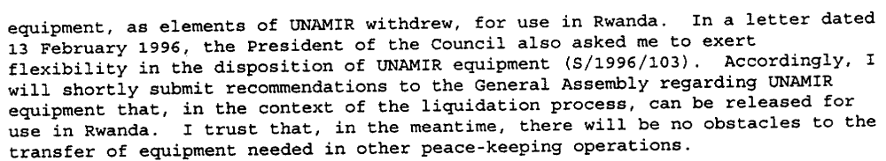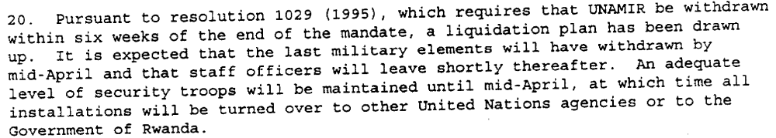(Report of the Secretary-General on the United Nations Assistance Mission for Rwanda, UN Doc. S/1996/149 (29 February 1996), par. 8, 10)

Assessment

Short-term compliance
No or marginal compliance (1) | Medium low compliance (2) | Medium high compliance (3) | Full or almost full compliance (4)

Considerations underlying the assessment
Although questions emerged about the manner of transfer of equipment and whether it could be transferred to Rwanda or brought out of the country to use in other peacekeeping missions, Rwanda did not in any way impede the ability of UNAMIR to withdraw in a safe and orderly manner.

Medium-term compliance

Description of the addressee(s)’ conduct
(UNAMIR’s mandate expired on March 8, 1996, within the six-month short term period after the demand was made. Its troops and personnel were removed shortly thereafter, negating the possibility of compliance or non-compliance by the Government of Rwanda.)

Assessment

Medium-term compliance
No or marginal compliance (1) | Medium low compliance (2) | Medium high compliance (3) | Full or almost full compliance (4)

Considerations underlying the assessment

(UNAMIR’s mandate expired on March 8, 1996, within the six-month short term period after the demand was made. Its troops and personnel were removed shortly thereafter, negating the possibility of compliance or non-compliance by the Government of Rwanda.)

Depth of demand

Assessment

Level of depth of demand
Low depth of demand (1) | Medium depth of demand (2) | High depth of demand (3)

Considerations underlying the assessment

The current Status of Mission Agreement governed relations for the final period of UNAMIR’s operations, in which it would finish its affairs and leave Rwanda. Since this is what Rwanda wanted, there was very little risk in helping it to do so.

Level of confidence about coding decisions

Level of confidence about coding decision
Extremely high | High | Moderate

Comments to IPI (if any)

The “moderate” coding decision is because I really don’t know what to do about the medium-term assessment; there is no assessment to make because UNAMIR’s mandate expired and was not renewed during the short term. You can change the medium-term coding to “not compliant”, but neither are really correct, because there was no UNAMIR to cooperate with.

Civil war in Rwanda

UNSC Resolution: | 1029
Date of adoption: | 12 December 1995
Operative paragraph: | 10
Demand number: | 1029.1012

Carla Winston

Wording of demand
Continue to facilitate their delivery and distribution

List of addressees of the demand
Government of Rwanda

Short-term compliance

Description of the addressee(s)’ conduct

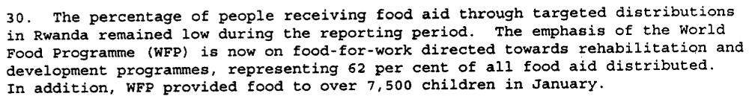(Report of the Secretary-General on the United Nations Assistance Mission for Rwanda, UN Doc. S/1996/149 (29 February 1996), par. 29-30)

Assessment

Short-term compliance
No or marginal compliance (1) | Medium low compliance (2) | Medium high compliance (3) | Full or almost full compliance (4)

Considerations underlying the assessment
No change from previous willingness to facilitate aid delivery and distribution, as circumstances within Rwanda would not change significantly until the mass return of refugees from Eastern Zaire and Tanzania in late 1996.

Medium-term compliance

Description of the addressee(s)’ conduct

For an international relief operation to work, the United Nations would need Rwanda's cooperation, aid officials said. The rebels have cut the road from Uganda to Goma over which most of the food for the camps was trucked, so food aid and medicine would have to be brought through Rwanda.
Mr. Ndahiro said Rwanda would be willing to allow relief supplies through, but only if the aid remained in Rwanda, as a lure to bring refugees back.

(“War in Eastern Zaire Leaves Relief Agencies Scrambling,” by James C. McKinley Jr. The New York Times, November 4, 1996. http://www.nytimes.com/1996/11/04/world/war-in-eastern-zaire-leaves-relief-agencies-scrambling.html?scp=10&sq=rwanda+humanitarian&st=nyt )

The Tutsi-led government of Rwanda also has authorized aid agencies to deliver food and medicine from its territory to Hutus in the rebel-held east.
(“Zairian Tutsi Rebels Permit Humanitarian Aid Corridor,” CNN, November 10, 1996. http://www.cnn.com/WORLD/9611/10/zaire/index.html

The Rwandan government has said so far that it welcomes international humanitarian aid but opposes the dispatch of foreign troops to its territory.

(“Refugees' swift exodus from Zaire slows 3-day journey of the 500,000Rwandans said to be largest, fastest ever.” Milwaukee Journal-Sentinel, November 18, 1996. http://www.highbeam.com/doc/1P2-6486632.html)

The supplies aboard the plane included 20 tons of flat beans, 15 tons of rice, two tons of cereals, and 2.5 tons of medicines. These were sent according to a list received from the Rwandan Government. The rice was donated by the Israeli Children's Society for Aiding Rwanda's Children.
The plane landed in Rwanda on Monday, December 2, and was met at the airport by the Rwandan Ministers of Rehabilitation, Health and Labor, as well as representatives of various international organizations W.F.P., F.A.O., W.H.O. and U.N.H.C.R. Local and international correspondents were also present.
The members of the Israeli mission visited the Runda transit camp, where food was distributed to refugees. In addition, they laid wreaths at the national Monument to Genocide, near Kigali. The Israeli mission was received by Rwandan ministers as well as the Vice President and Defense Minister, Paul Kagame. They all expressed their deep appreciation and esteem toward Israel for the dedicated, helpful and rapid aid operation.
(Israeli Ministry of Foreign Affairs, “Humanitarian Aid to Rwanda, 4 December 1996.” http://www.mfa.gov.il/MFA/About+the+Ministry/MFA+Spokesman/1996/HUMANITARIAN%20AID%20TO%20RWANDA%20-%2004-Dec-96 )

Assessment

Medium-term compliance
No or marginal compliance (1) | Medium low compliance (2) | Medium high compliance (3) | Full or almost full compliance (4)

Considerations underlying the assessment
Although it initially preferred that all humanitarian aid destined for returning refugees remain inside Rwanda, in short order the Government of Rwanda changed its mind and allowed its territory to be used as a base for sending humanitarian relief supplies into eastern Zaire.

Depth of demand

Assessment

Level of depth of demand
Low depth of demand (1) | Medium depth of demand (2) | High depth of demand (3)

Considerations underlying the assessment

As the Government of Rwanda did not have the ability to fully aid its own internally displaced persons, due to lack of capacity, it was in the Government’s best interests to aid international organizations to distribute donated aid to those in need.

Level of confidence about coding decisions

Level of confidence about coding decision
Extremely high | High | Moderate

Comments to IPI (if any)

It was difficult to find sources on Rwanda’s compliance in distributing humanitarian aid after the end of UNAMIR’s mandate.

Civil war in Rwanda

UNSC Resolution: | 1029
Date of adoption: | 12 December 1995
Operative paragraph: | 12
Demand number: | 1029.1211

Carla Winston

Wording of demand

Cooperate fully with the International Commission of Inquiry established pursuant to resolution 1013 (1995)

List of addressees of the demand

Government of Rwanda

Short-term compliance

Description of the addressee(s)’ conduct

13. The International Commission, having established an administrative base at the United Nations Office at Nairobi, visited Rwanda and Zaire and met in each country with senior government officials and the heads of United Nations agencies and representatives of NGOs operating among the refugees (see appendix).

16. That afternoon, the International Commission met with the Minister of Foreign Affairs of Rwanda, H.E. Mr. Anastase Gasana. The Commissioner met the following morning with the Vice-President and Minister of Defence, Major-General Paul Kagame.
17. During the meeting with the Vice-President, in addition to requesting general assistance in the discharge of the Commission’s mandate, the Chairman requested the particular cooperation of the Rwandese Government in facilitating a visit by the Commission to Iwawa island in Lake Kivu. The island, which is Rwandese territory, had been the scene of a battle a few days before between the Rwandese Patriotic Army (RPA) and Rwandan insurgents apparently controlled by the former Rwandan government forces. A quantity of weapons and military matériel, as well as a number of prisoners, had been captured there.
18. The Commission’s visit to Iwawa island took place the next day, 10 November 1995. The danger from land-mines, which had been heavily and indiscriminately laid on the island, and the time constraints imposed by limitations on the means of transportation available, prevented the Commission from undertaking a comprehensive study of the site and interviewing in depth the prisoners presented to it.
19. Nevertheless, the Commission was able to inspect weapons, explosives and other military equipment both on the shore and at another site further inland. Most of the weapons inspected were found to be old and unserviceable, while the new matériel, still wrapped in plastic bags, mostly comprised unassembled machine-guns. The Commission was later informed by the RPA senior officer present that some weapons in working order had been removed from the island and distributed among the RPA, but that none of these had been new.
20. The Chairman and some members of the Commission then interviewed some young men and a senior non-commissioned officer of the former Rwandan government forces who, they were informed by the RPA officer present, had been captured on the island. The Commission members were obliged to use the RPA officer as an interpreter in their interviews, but had no reason to doubt that the interpretation was accurate. The young men were informed of the nature of the International Commission and agreed to answer questions posed by it. The answers they gave indicated that the men were Rwandans, and had been living in Mugunga Camp near Goma, Zaire. They had been undergoing elementary weapons training on the island under the supervision of a military commander of the former Rwandan government forces and a civilian. No foreigners were said to be involved.
21. During its stay in Rwanda, the International Commission also met with representatives of the Office of the United Nations High Commissioner for Refugees (UNHCR) and other United Nations agencies, the International Committee of the Red Cross (ICRC) and a number of NGOs, as well as representatives of major donor countries (see annex). The Commission also established direct working-level links with Rwandan government officials.
22. During November and December 1995, Commission members travelled back to Kigali from time to time to meet with officials there in an effort to gather and analyse as much information as possible that might corroborate the allegations under investigation. However, on the basis of the information made available to it through this channel to date, the Commission has not been able to reach a firm conclusion as to the truth of the allegations.
(Interim report of the International Commission of Inquiry to investigate reports of the sale or supply of arms to former Rwandan government forces in violation of the Security Council arms embargo and allegations that those forces are receiving training to destabilize Rwanda, UN Doc. S/1996/67 Annex 1 (29 January 1996), par. 13, 16-22)

(Report of the International Commission of Inquiry (Rwanda), UN Doc. S/1996/195 Annex 1 (14 March 1996), par. 19)

Assessment

Short-term compliance
No or marginal compliance (1) | Medium low compliance (2) | Medium high compliance (3) | Full or almost full compliance (4)

Considerations underlying the assessment

As it was the Government of Rwanda making claims that arms and materiel were flowing to the forces of the former Government, it was in Rwanda’s best interests to cooperate fully with the Commission as it attempted to discern whether the claims were true.

Medium-term compliance

Description of the addressee(s)’ conduct

10. The Commission visited Rwanda from 24 to 29 July [1996] and met there with the Vice-President and Minister of Defence, Major-General Paul Kagame, and other senior officials to renew contacts made earlier. In addition, one Commissioner visited Rwanda a number of times in August and September to maintain official and unofficial contacts, inspect captured weapons and interview prisoners captured in cross-border incursions from Zaire.
11. The Commission was informed that the number and duration of such incursions were increasing and they were penetrating deeper into Rwanda. Some originated in Bukavu and Uvira and came up through Burundi into the south of Rwanda. 12. The information acquired by the Commission concerning fund-raising by and arms sales and deliveries to the former Rwandan government forces and military training to destabilize Rwanda is dealt with in detail below.
(Third report of the International Commission of Inquiry (Rwanda), UN Doc. S/1997/1010 Annex (24 December 1997), par. 10-12)

Assessment

Medium-term compliance
No or marginal compliance (1) | Medium low compliance (2) | Medium high compliance (3) | Full or almost full compliance (4)

Considerations underlying the assessment

As The Government of Rwanda was concerned with arms flowing to the forces of the Former Government of Rwanda, it was in its interests to cooperate as fully as possible with the Commission in order to prove its claims.

Depth of demand

Assessment

Level of depth of demand
Low depth of demand (1) | Medium depth of demand (2) | High depth of demand (3)

Considerations underlying the assessment

Complying with the demand could actually help improve the Government’s position vis-à-vis the rebels, since uncovering evidence of illegal arms transfers could lead to their interruption, and the weakening of the ability of the Ex-Rwandan Government forces to conduct attacks on Rwandan territory.

Level of confidence about coding decisions

Level of confidence about coding decision
Extremely high | High | Moderate

Comments to IPI (if any)

